1. Find First Palindromic String in the Array (easy)

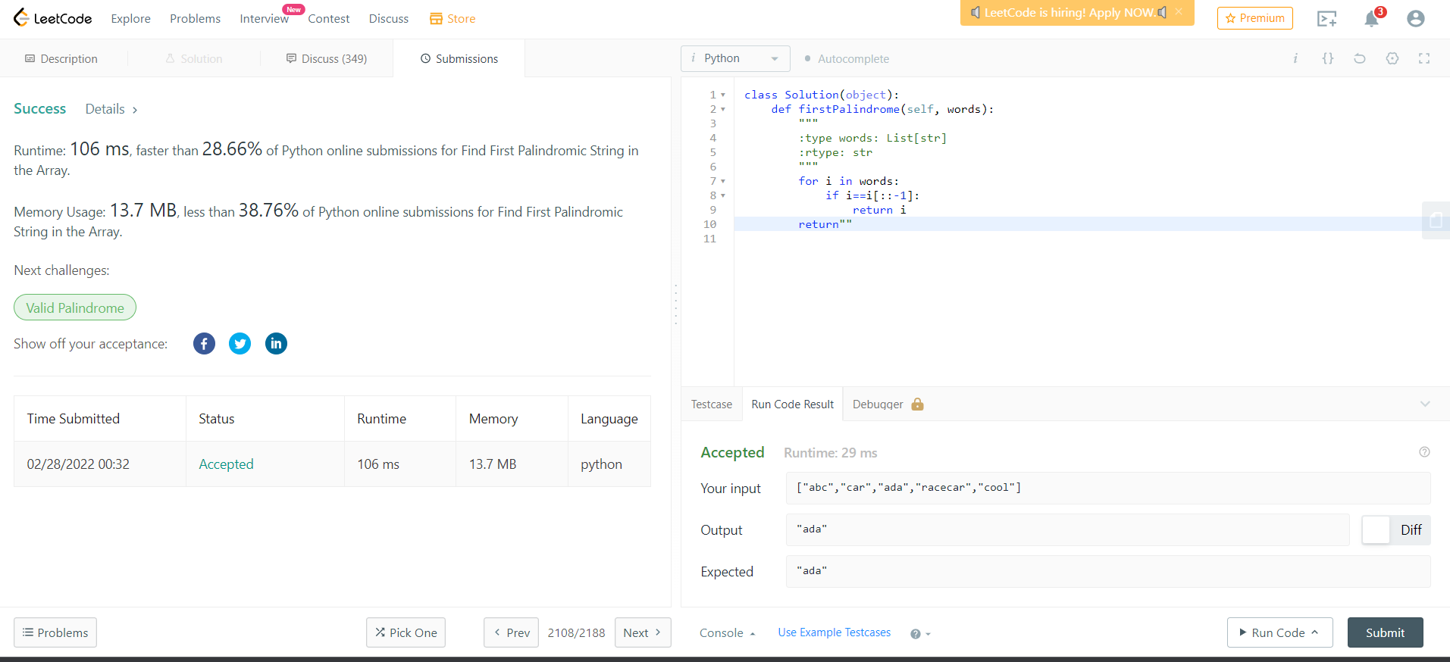

1. Merge Sorted Array (Easy)

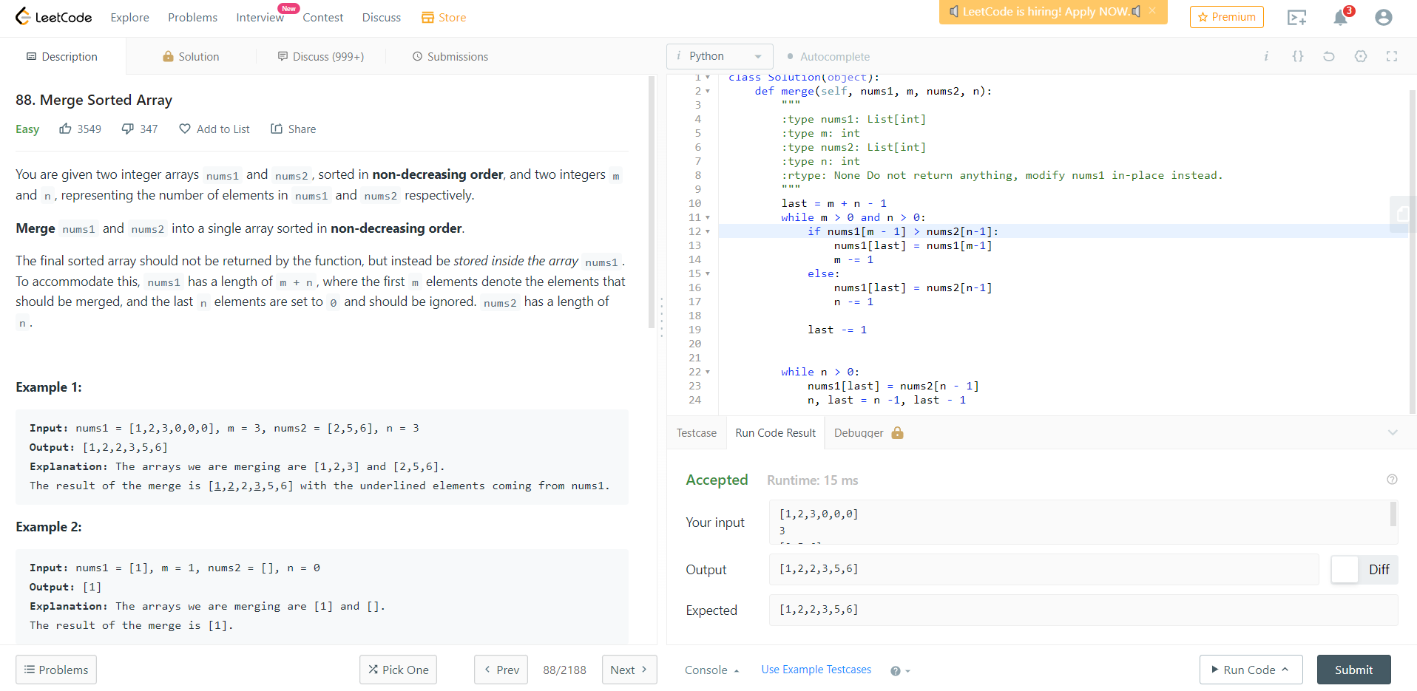

1. Monotonic Array (Easy)

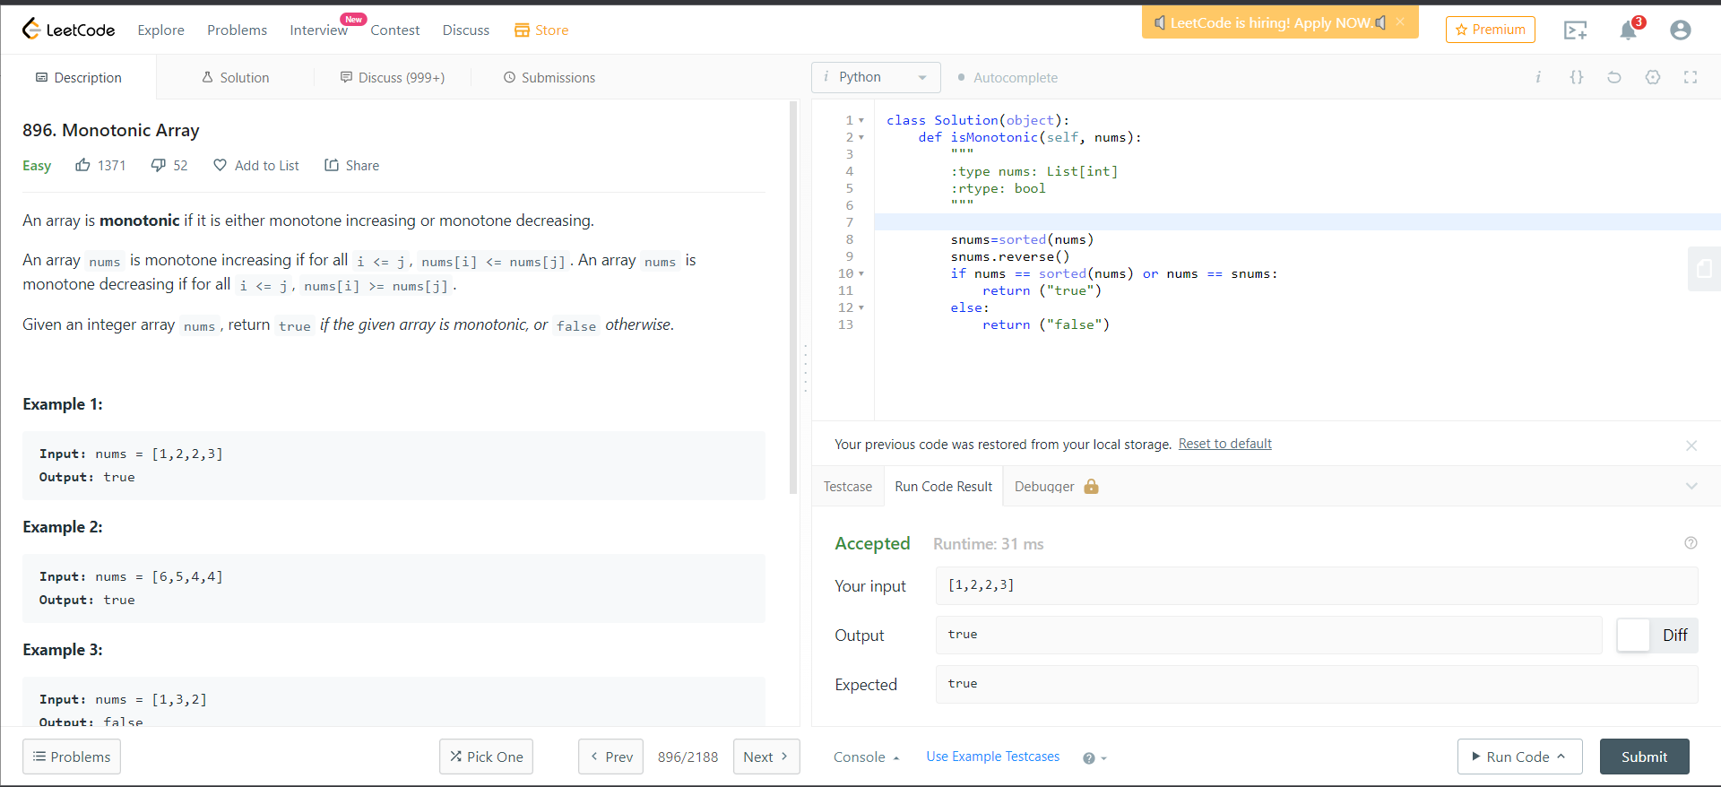

1. Palindrome (Easy)

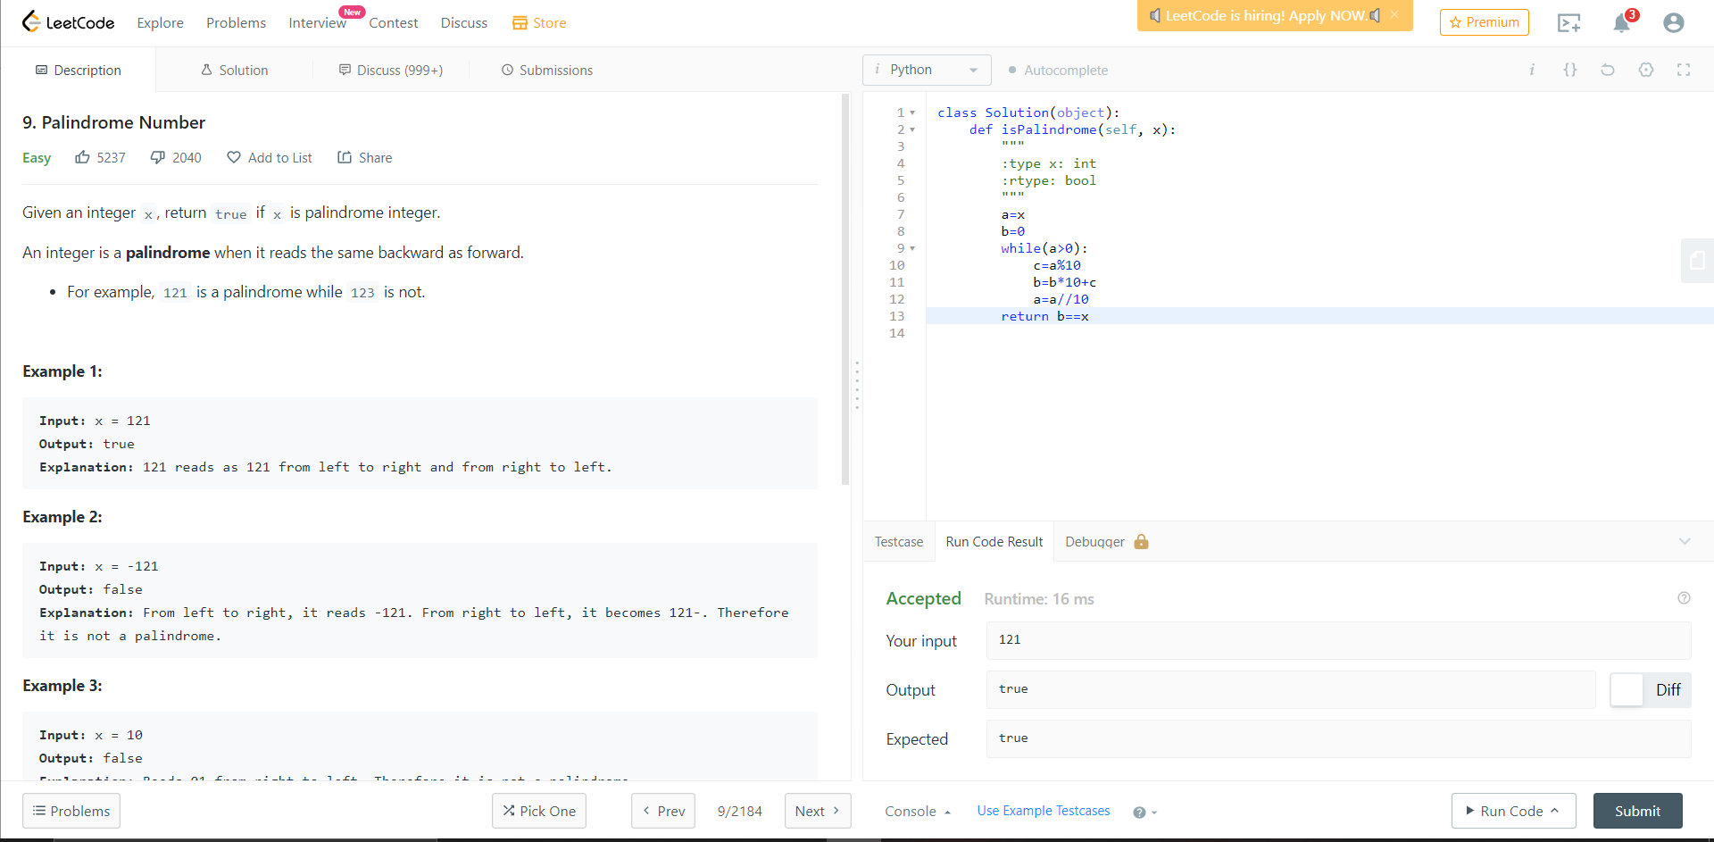

1. plus 1 (easy)

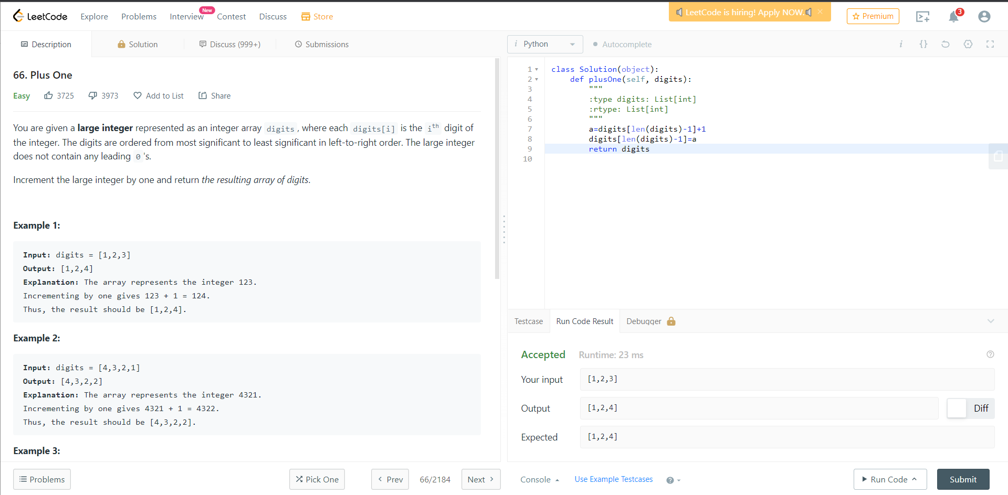

1. Two Sum (Easy)



1. Two Sum II - Input Array Is Sorted (medium)

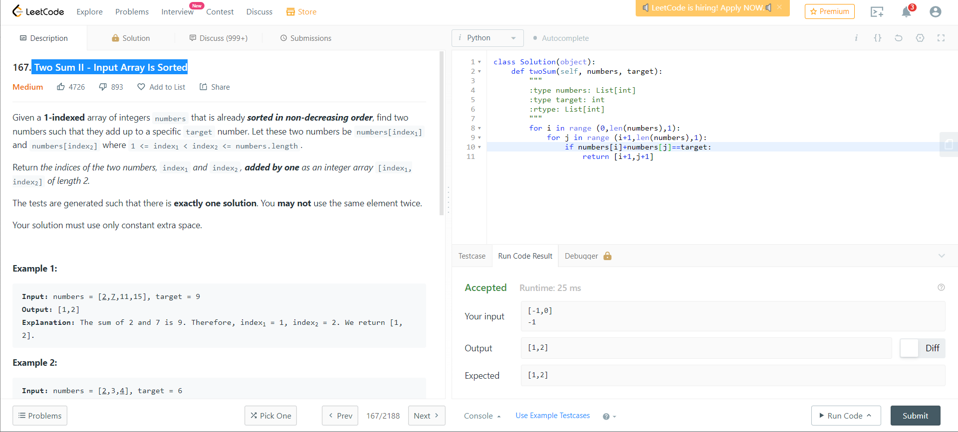

1. Container With Most Water (Medium)

